Assignment 1 Report
CIS 310-001

Design choices for registers and SRAM:
Provided in class: 8-bit register, General Purpose Register, Program Counter.
(I’ll still go over them, however, to explain their functions. The assigned problems we had to work on ourselves, though, were the IR and SRAM, so that’s where explaining my design choices is applicable.

8-bit register: This reaches to a few lectures ago, but this register is meant to take 2-bits of control signals to either Load, Store the input, Clear the register, or set the register to FF. It’s made up of 8 D flip-flops and uses a multiplexer with a splitter to apply the control functions to the flip-flops, then merging their outputs into an 8-bit output with the merger.

General Purpose Register: This register takes 4 of the previous registers, labeled R1, R2, R3, and R4 as per instruction, and applies the same set of control functions to them. However, we select the register we plan to use with the RegisterSelection input. To ensure we don’t change all registers at once, that input is fed into a decoder and split into 4 lanes, which connect to 4 AND’s with the clock clk. Each AND outputs to each individual 8-bit register’s AND input. As a result, only the chosen register from RegisterSelection will trigger and apply the control function and take input on clock pulse.

Program Counter: The program counter is really only an 8-bit register given new functionality by making use of an 8-bit ripple-carry adder, to allow the values stored in the register to increase by a given amount, specified by input Incby, on each clock pulse. If Incby is 2 for example, and we set out control to 01, which is now Increment, our register will add 2 to its stored value on each clock pulse. The full adder takes the current register output as input, allowing it to continuously increase until it passes 8 bits and overflows, wrapping mod 256 and continuing to increment. However, as asked for by the requirements, I implemented a ManualJump input that takes an 8 bit value, and sets the register to that value on load as a sort of manual override for any desired jump operations.

Instruction Register: I decided to follow the example set by the 8-bit register for the instruction register, as the instruction register’s function is to hold or load a value, rather than have the added functionalities that come with the 8-bit register, so I was able to adapt the 8-bit register’s design to the IR by only allowing the hold and load input to the multiplexer, and reducing the number of selector bits to 1, taking only the output and input on those pins. In testing, it functions and outputs as intended. It should be noted that I was unsure if I was allowed to change the naming conventions to include hold, as instructions stated to “Add control signals for Load (LD)”, so “hold” is “load output” and “load” is “load input”. Not any difference in functionality, but I wanted to make sure it fit the expected format, so that’s why it’s named as such.

SRAM: Part of this design was already provided earlier when expanding on the use of 8-bit registers in class, so I took that implementation and converted it into functional SRAM by expanding the number of registers to 16, allowing for 16 different addresses. The decoder takes the selected address input and, using an AND with the clock input, chooses which 8-bit register the function in control will be applied to. The SRAM can load, store, clear, or setFF, with inputs ctrl, Datainput, Addresspin, and the clock. It outputs to Dataoutput using a multiplexer which takes the outputs of all 16 8-bit registers.

Control signals used:
8-bit register:
00->Load
01->Store
10->Clear
11->Set FF
General Purpose Register:
00->Load
01->Store
10->Clear
11->Set FF
Program Counter:
ctrl signals:
00->Load
01->Increment
10->Reset
11->Set FF
Instruction Register:
0->Load IR output (hold)
1->Load IR input
SRAM:
00->Load
01->Store
10->Clear
11->Set FF

Test results:
GPR: Load values into each register and verify their content using output pins.
Storing 120 to Register 0:
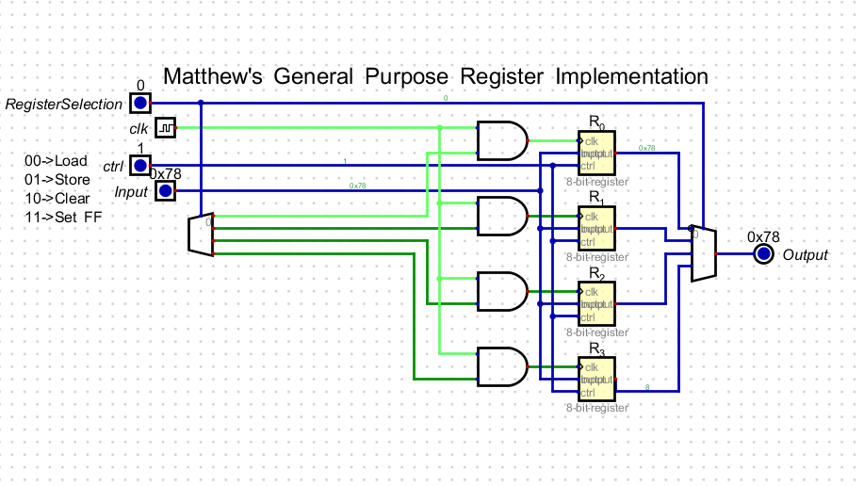
Load Register 3’s content (contains 8, should output 8):
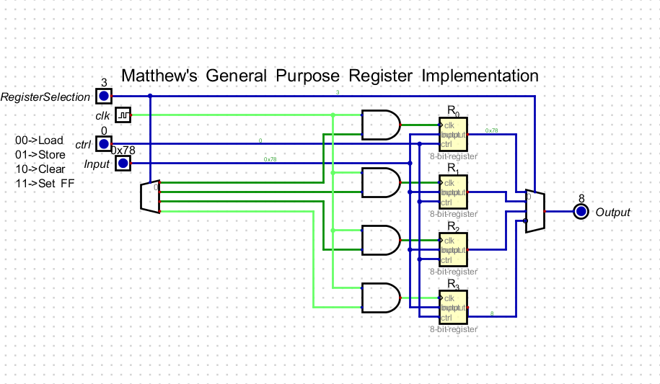

Set Register 1 to FF:
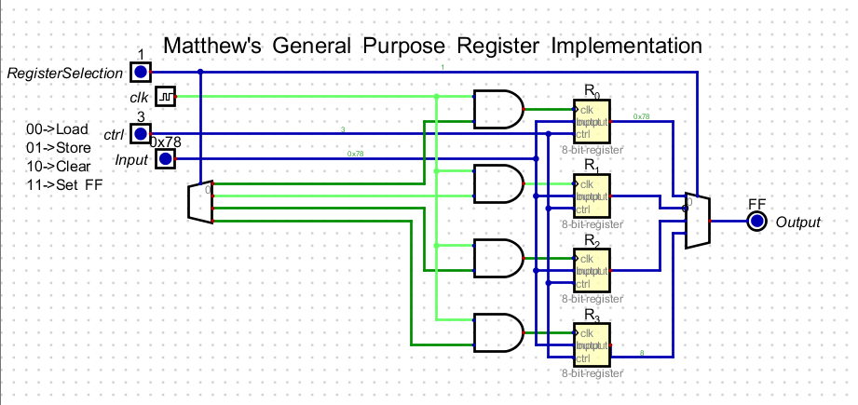
Clear Register 0:
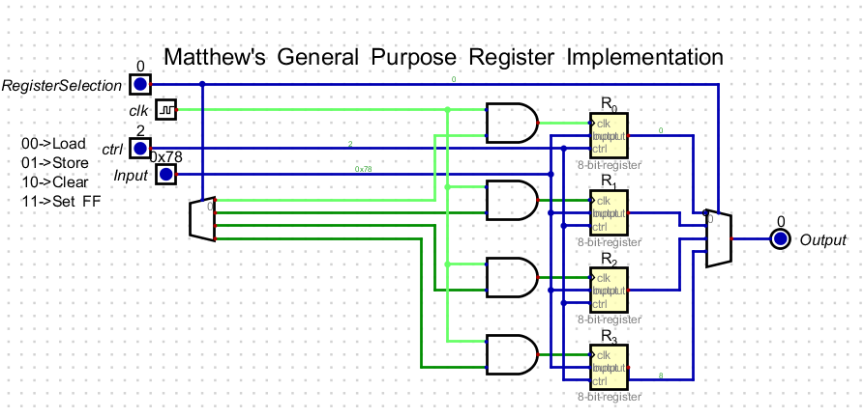
PC:
- Verify that PC increments correctly when INC = 1.
- Load a custom address into PC using LD = 1 and check if the jump works.
- Reset PC to 0000 using RST = 1.

1. Verify PC increments correctly when inc = 1:
Before ctrl = 01, inc = 1: (Output is 0)
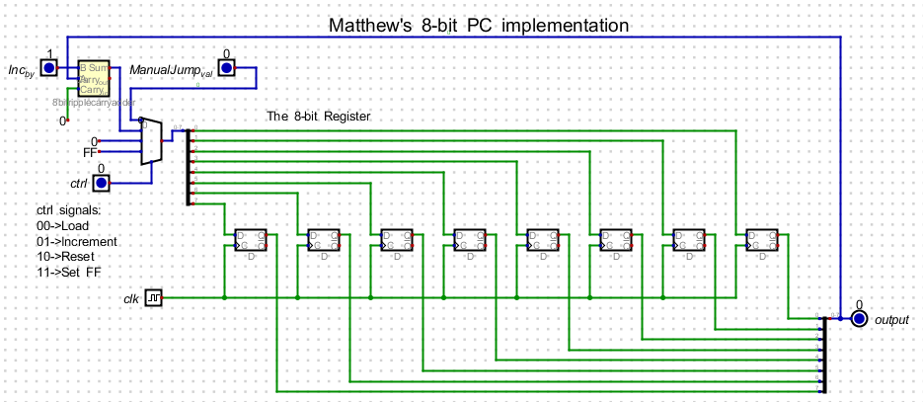
Clock pulse after ctrl = 01, inc = 1: (Output is now 1)
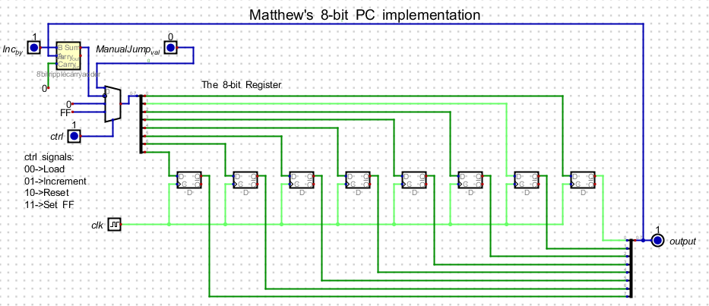

Next clock pulse: (Output is now 2)
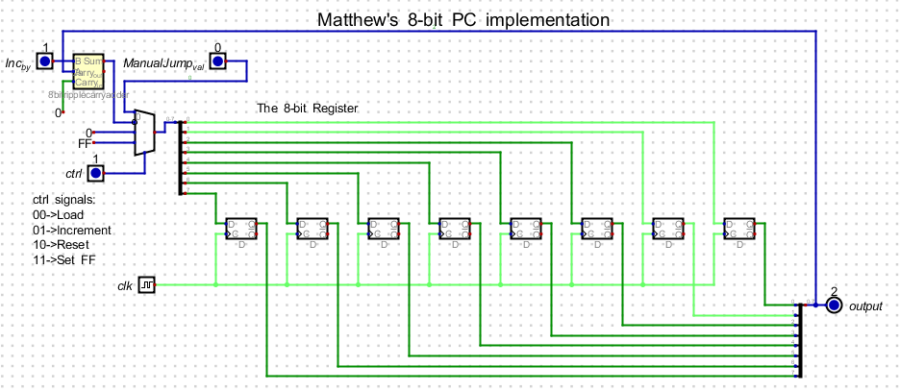

2. Load a custom address into PC using LD = 1 and check if the jump works
Pre-Jump (ManualJump set to 88, ctrl set to load, before clock pulse):
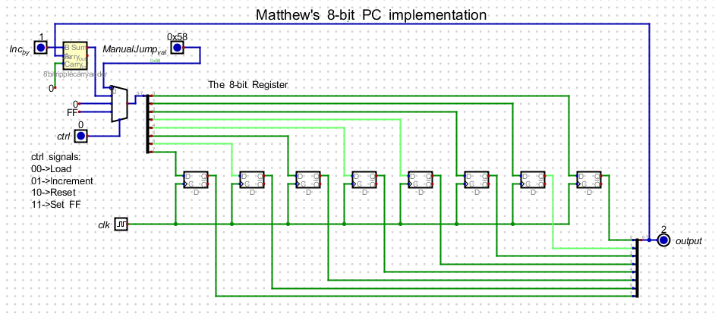

Post-Jump (After clock pulse):
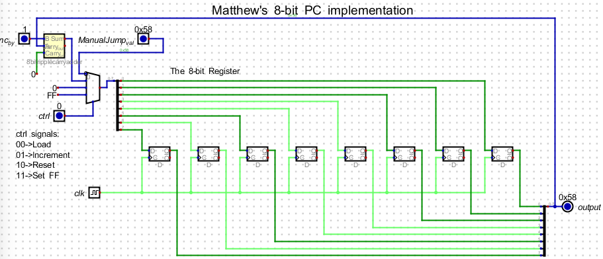
3. Reset PC to 0000 using RST = 1
Pre-Reset (ctrl set to reset, before clock pulse):
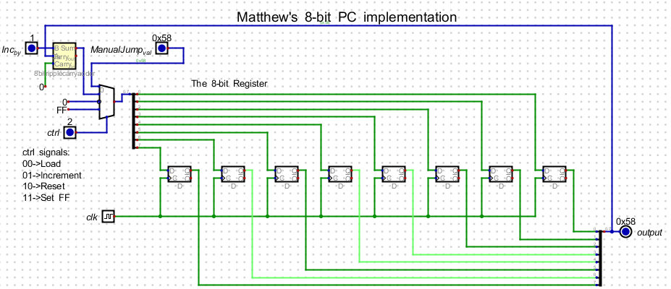
Post-Reset (after clock pulse):
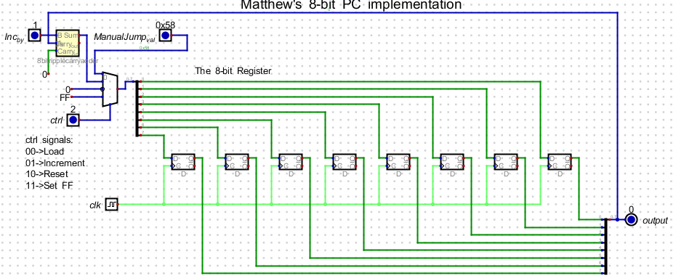

IR: Load different instruction values and verify the output.
Input 2, ctrl 0 (should output 0 as IR is empty, holding 0):
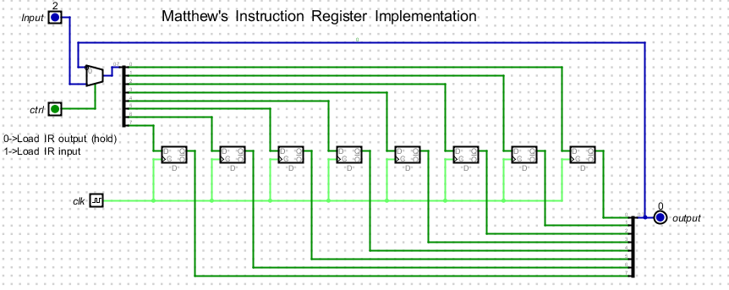

Input 2, ctrl 1 (should output 2 after loading input):
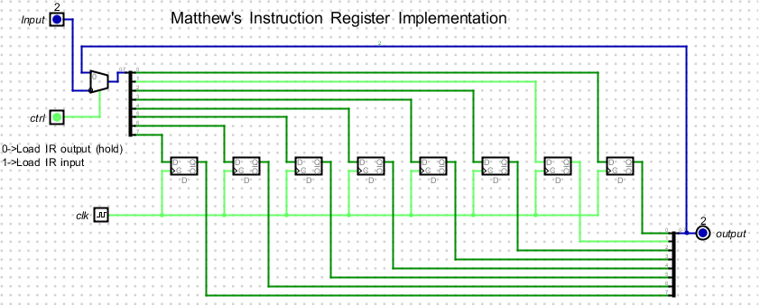
Input 255, ctrl 0 (should output 2 from holding output):
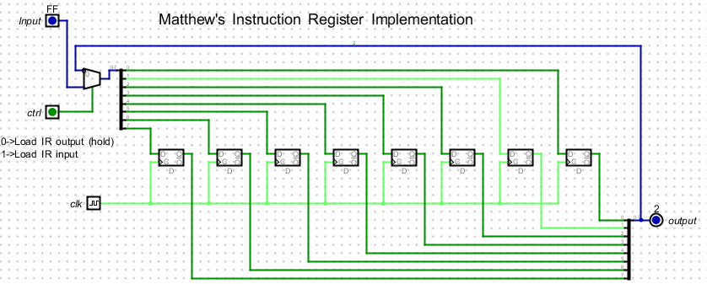
Input 255, ctrl 1 (should output 255 [FF] after loading input):
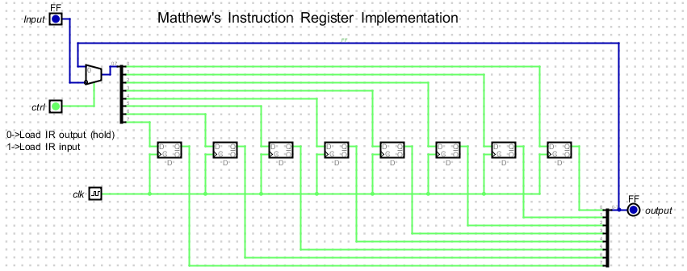

SRAM: Write values to specific addresses and read them back.
Writing 6 to Register 7:
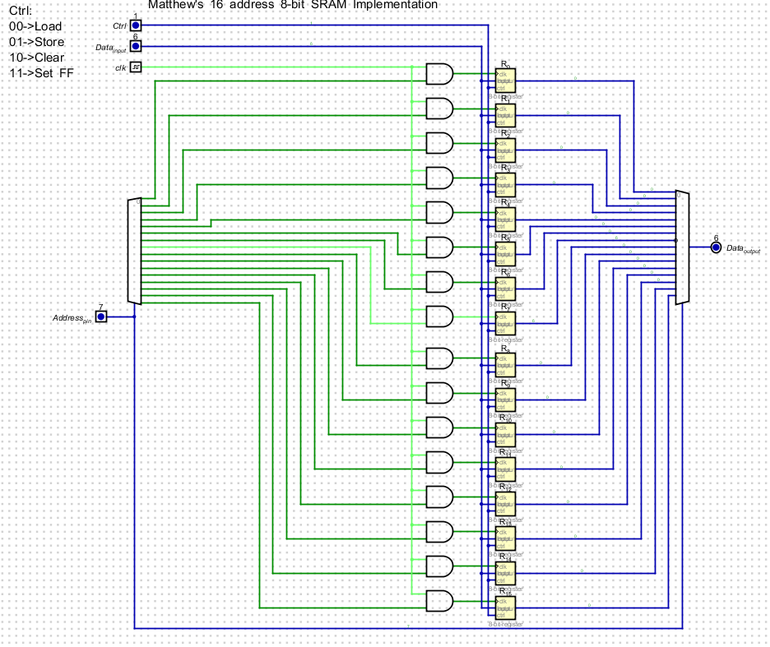

SetFF on Register 0 (input = 6 should have no effect):
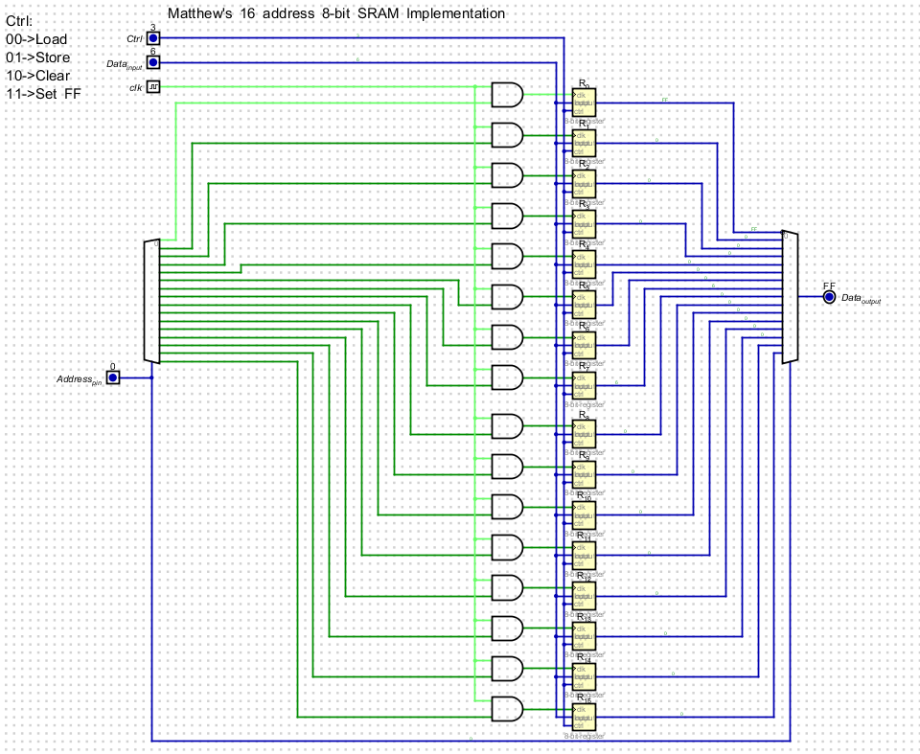

Writing 48 to Register 12:
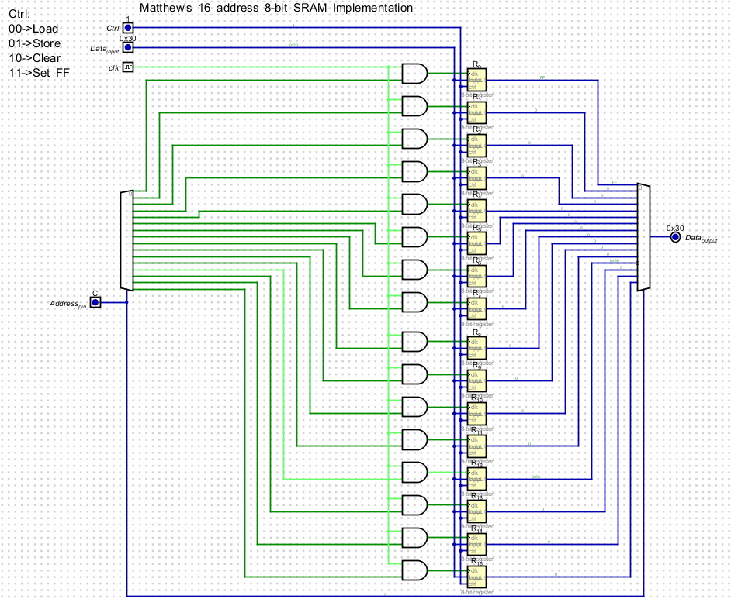

Load Register 7 while input is still 48 (Should output 6):
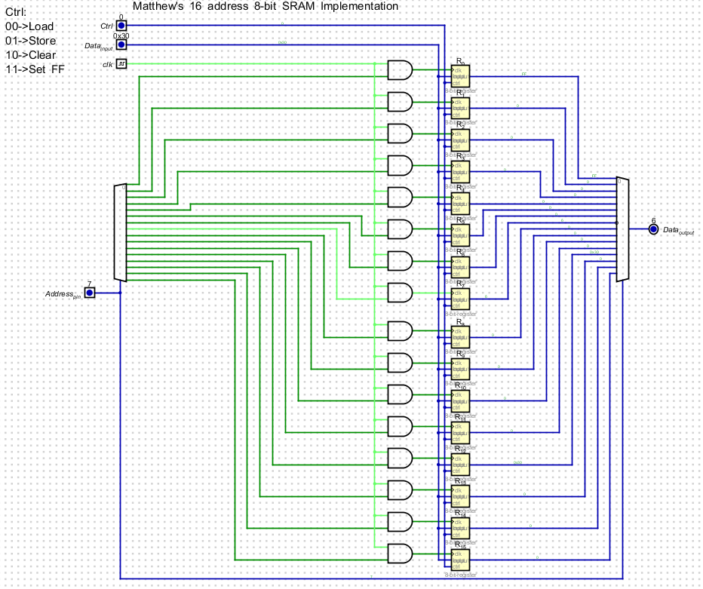

Clear Register 7:
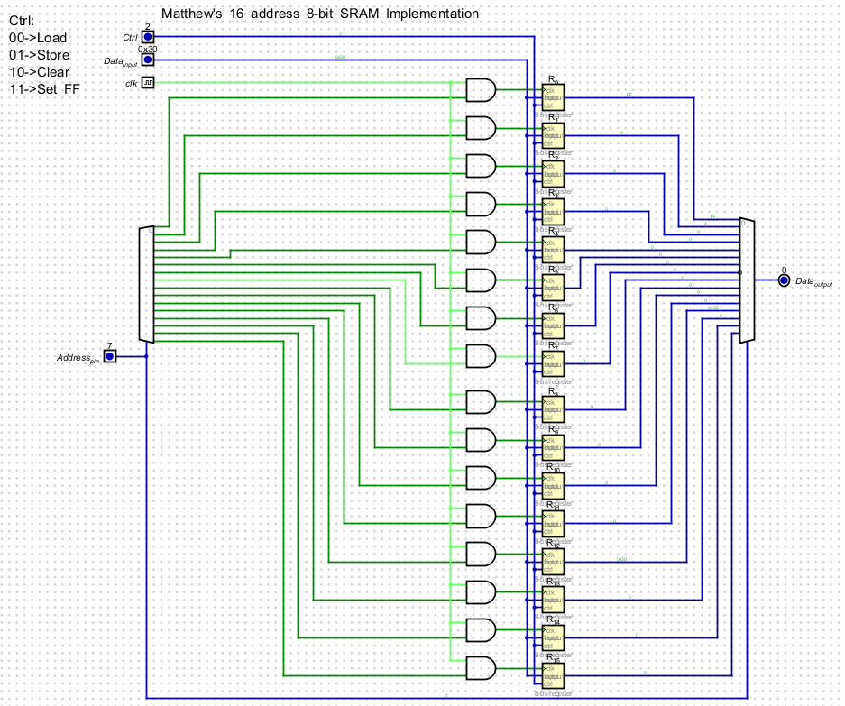

Load Register 7 after it’s been cleared:
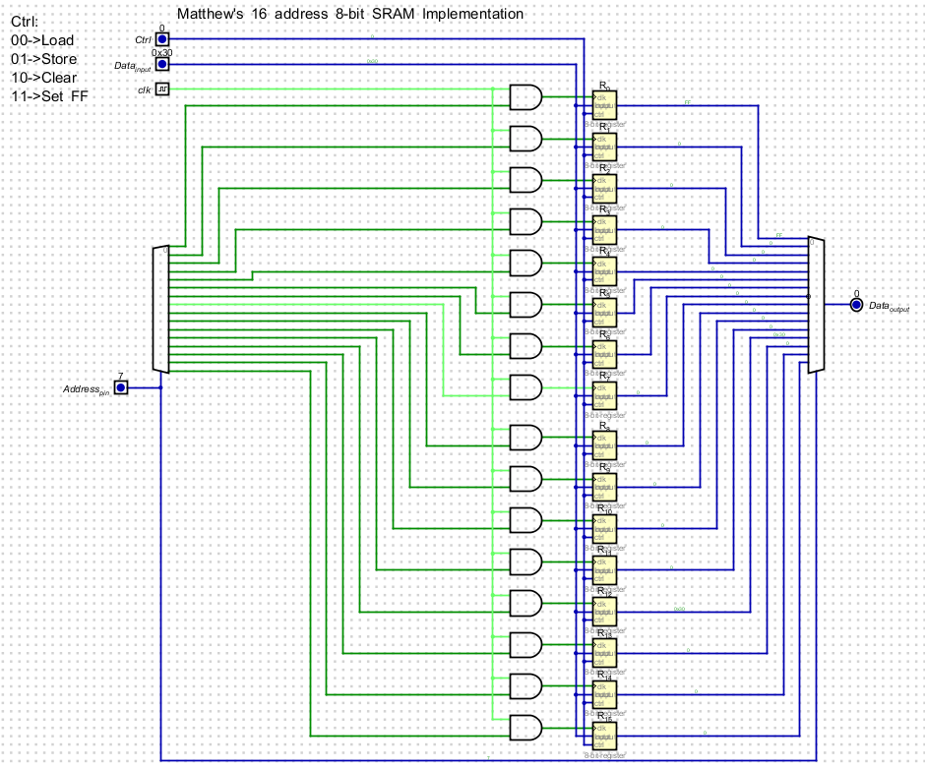

Load Register 0 (should output FF):
